**5. EVALUATION OF VOLUME UNDER A SURFACE BY DOUBLE INTEGRAL**

**Aim: To evaluate the volume under surface using double integral and to visualize the same using MatLab.**

**Statement of the problem:** Evaluate and visualize the volume represented by the double integral

|  |  |
| --- | --- |
|  | (1) |

Above integral represents volume of the region below the surface and above the plane . This integral can also be setup in the following way (by changing the order of integration of x and y):

|  |  |
| --- | --- |
|  | (2) |

**Solution Approach:** We evaluate the double integrals by repeated application of the symbolic toolbox command for integration that, on applying twice, will read as**:**

Further, to visualize the volume in MatLab we make use of two additional MatLab functions (provided by MathWorks) viz. “viewSolid” and “viewSolidone”. These supporting function files can be downloaded from the link [**ftp://10.30.2.53/MATLAB/**](ftp://10.30.2.53/MATLAB/).

The first function “viewSolid” is used to visualize the integrals in which the order of integration is as given in (1) and “viewSolidone” is for the integrals of the form (2).

What follows is the syntax for using “viewSolid” and “viewSolidone” commands:

|  |
| --- |
| viewSolid(z,0,f(x,y),y,y1(x),y2(x),x,x1,x2)  viewSolidone(z,0,f(x,y),x,x1(y),x2(y),y,y1,y2) |

It should be observed that the “viewSolid” command is used when y1 and y2 are functions of x whereas x1 and x2 are constants. The “viewSolidone” command is used in the reverse case. Now we consider few examples for illustration of the approach mentioned above.

**Example 1:**

Set up a double integral to find the volume of a sphere of unit radius.

**Solution:**

Let the sphere be . We know that due to the symmetry the volume of the sphere is 8 times its volume in the first octant. Thus we setup a double integral to find the volume below the surface of the sphere in the first octant only and write the total volume as:

**MATLAB Code:**

clc

clear all

syms x y z

vol=8*int(int(sqrt(1-x^2-y^2),y,0,sqrt(1-x^2)),x,0,1)

double(vol)

viewSolid(z,0+0*x*y,sqrt(1-x^2-y^2),y,0+0*x,sqrt(1-x^2),x,0,1);

axis equal; grid on;

viewSolid(z,-sqrt(1-x^2-y^2),sqrt(1-x^2-y^2),y, -sqrt(1-x^2),sqrt(1-x^2),x,-1,1);

|  |
| --- |
| clc  clear all  syms x y z  vol=8*int(int(sqrt(1-x^2-y^2),y,0,sqrt(1-x^2)),x,0,1)  figure(1)  viewSolid(z,0+0*x*y,sqrt(1-x^2-y^2),y,0+0*x,sqrt(1-x^2),x,0,1); axis equal; grid on;  figure(2)  viewSolid(z,-sqrt(1-x^2-y^2),sqrt(1-x^2-y^2),y, -sqrt(1-x^2),sqrt(1-x^2),x,-1,1); |

Output:

vol =

(4*pi)/3

\

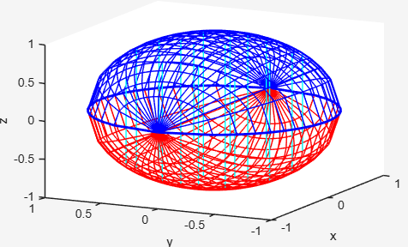

**Example 2:**

Find the volume of the solid that lies under the paraboloid and above the region D in the -plane bounded by the lines and the parabola

**Solution:**

The double integral for this problem can be setup as:

clc

clear all

syms x y z

vol = int(int(x^2+y^2, x,y/2,sqrt(y)), y, 0, 4)

viewSolidone(z,0+0*x*y,x^2+y^2,x,y/2,sqrt(y),y,0,4);

grid on;

**MATLAB Code:**

|  |
| --- |
| Clc  clear all  syms x y z  vol = int(int(x^2+y^2, x,y/2,sqrt(y)), y, 0, 4)  viewSolidone(z,0+0*x*y,x^2+y^2,x,y/2,sqrt(y),y,0,4); grid on |

**Output:**

vol =

216/35



**Example 3:**

Consider the following mathematical problem

Evaluate  where 

Given below is the Matlab code for the above problem.

## MATLAB Code:

clc

clear all

syms x y z

viewSolid(z,0+0*x+0*y,x-3*y^2+0*y,y,1+0*x,2+0*y,x,0,2)  
int(int(x-3*y^2+0*y,y,1,2),x,0,2)

## Output:

In the Command window:

>> ans

-12

In the Figure window:

0

0.5

1

1.5

2

1

1.5

2

-12

-10

-8

-6

-4

-2

0

x

y

z

## Inference:

In this figure the required volume is below the plane z=o (shown in red) and above the surface z=(x-3y^2)(shown in green) . The reason why the answer is negative is that the surface z=(x-3y^2) is below z=0 for the given domain of integration.

## Example 4:

Evaluate  where 

## MATLAB Code:

## clc

**clear all**

**syms x y z**

**viewSolidone(z,0+0*x+0*y,y*sin(x*y),x,1+0*y,2+0*y,y,0,pi)  
int(int(y*sin(x*y),x,1,2),y,0,pi)**

## Output:

In the Command window:

>> ans

0

In the Figure window:



## Inference:

For a function f(x,y) that takes on both positive and negative values is a difference of volumes V1-V2, V1 is the volume above R and below the graph of f and V2 is the volume below R and above the graph. The integral in this example is 0 means V1=V2

**Converting Cartesian to polar coordinates**

**Example 5:**

Find the volume of the solid bounded by the plane z=0 and the paraboloid

Sol:

By changing the coordinates from Cartesian to Polar we get

clc

clear all

syms r theta

V = int(int((1-r^2)*r, r, 0, 1), theta, 0, 2*pi)

fsurf(r*cos(theta),r*sin(theta), 1-r^2, [0 1 0 2*pi], 'MeshDensity', 20)

axis equal; axis([-2 2 -2 2 0 1.3])

xticks(-2:2); yticks(-2:2); zticks(0:1.3)

xlabel('x'); ylabel('y')

**Output**

V = pi/2

Figure window:

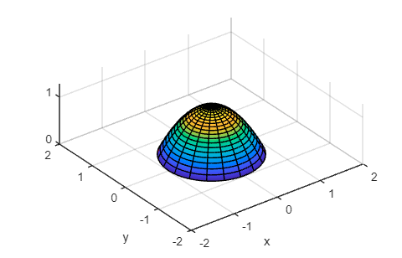

**Example 6**

Find the volume of the solid that lies under the paraboloid and above the xy- plane, and inside the cylinder

Sol:

By changing the coordinates from Cartesian to Polar we get

Matlab code

clc

clear all

syms r theta z r1

V = int(int((r^2)*r, r, 0,2*cos(theta) ), theta, -pi/2, pi/2)

r = 2*cos(theta), x = r*cos(theta), y = r*sin(theta)

fsurf(x,y,z, [0 2*pi 0 1], 'MeshDensity', 16)

axis equal; xlabel('x'); ylabel('y'); zlabel('z')

zticks(0:1.5)

hold on

fsurf(r1*cos(theta),r1*sin(theta),r1^2, [0 1 0 2*pi], 'MeshDensity', 20)

Output:

V = (3*pi)/2

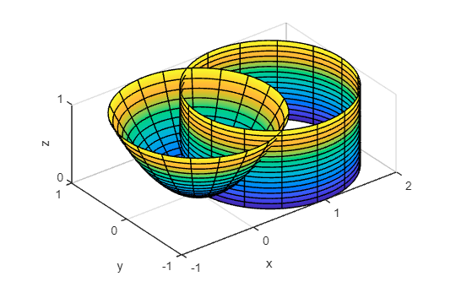

**Exercise Problems:**

1. Set up a double integral to find the volume of the *hoof of Archimedes,* which is the solid region bounded by the planes , and the cylinder
2. Write an iterated integral to view the volume enclosed by the cone and the plane . Hence find the volume.
3. Find the volume of the solid bounded by the elliptic paraboloid the planes and and the three coordinate planes.
4. Use polar coordinates to find the volume of the solid that lies under the cone and above the disk